COUNTY OF IMPERIAL
REQUEST FOR PROPOSAL 1006-23

SALTON SEA RENEWALBLE RESOURCE
HEALTH IMPACT ASSESSMENT

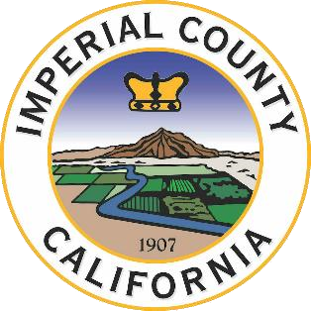
Coordinating Agency
IMPERIAL COUNTY PUBLIC HEALTH DEPARTMENT

November 22, 2022
Addendum #1

The exhibits below have been reformatted to print on a single page each. Please use these new formatted pages of the exhibits when turning in your proposal.

A- PROPOSAL CHECKLIST
B- PROPOSAL COVER SHEET
C- BUDGET
D- NON-DISCRIMINATION COMPLIANCE
E- SMOKE-FREE ENVIRONMENT STATEMENT

Please feel free to reach out to debbiewray@co.imperial.ca.us if you have any questions or concerns.

